ACF Lab 6: Scale and Load Balance Your Architecture

Student name: Duy Hung D Student ID: 104182779

Tutorial session: Monday 1:00PM

1. INTRODUCTION

In Amazon Web Services (AWS), scaling and load balancing are crucial components for ensuring optimal performance and availability of applications. Scaling refers to the ability to dynamically adjust computing resources in response to varying workloads. AWS offers both vertical scaling, achieved by resizing individual instances, and horizontal scaling, achieved by adding or removing instances to distribute traffic efficiently. Load balancing plays a key role in horizontal scaling by evenly distributing incoming application traffic across multiple instances. AWS provides a service called Elastic Load Balancing (ELB) to automatically distribute incoming application traffic across multiple Amazon EC2 instances, enhancing fault tolerance and ensuring that no single instance is overwhelmed with excessive load. By combining scalable resources and load balancing, AWS enables applications to seamlessly handle fluctuating demand, enhance fault tolerance, and optimize performance for a reliable and responsive user experience.

1. Main

**Task 1: Create an AMI for Auto Scaling**

Select EC2 in Services menu, and then choose instances to see the dislplays 2/2 checks passed from Web Server 1.

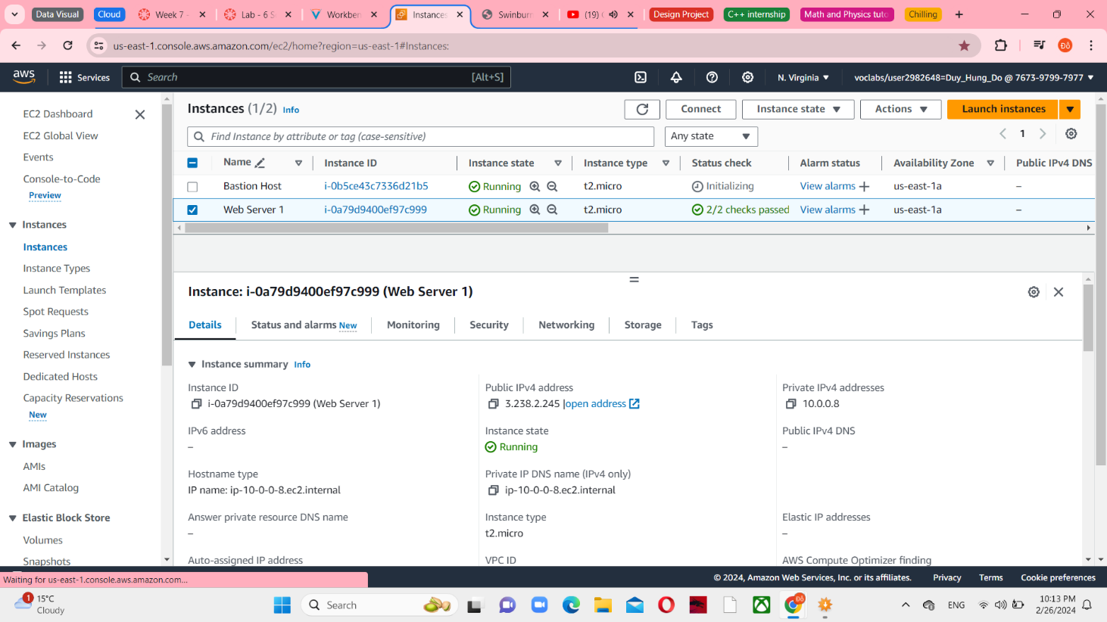

*Figure 1 EC2 Instances*

Select Web Server 1 and Create image in Actions menu.

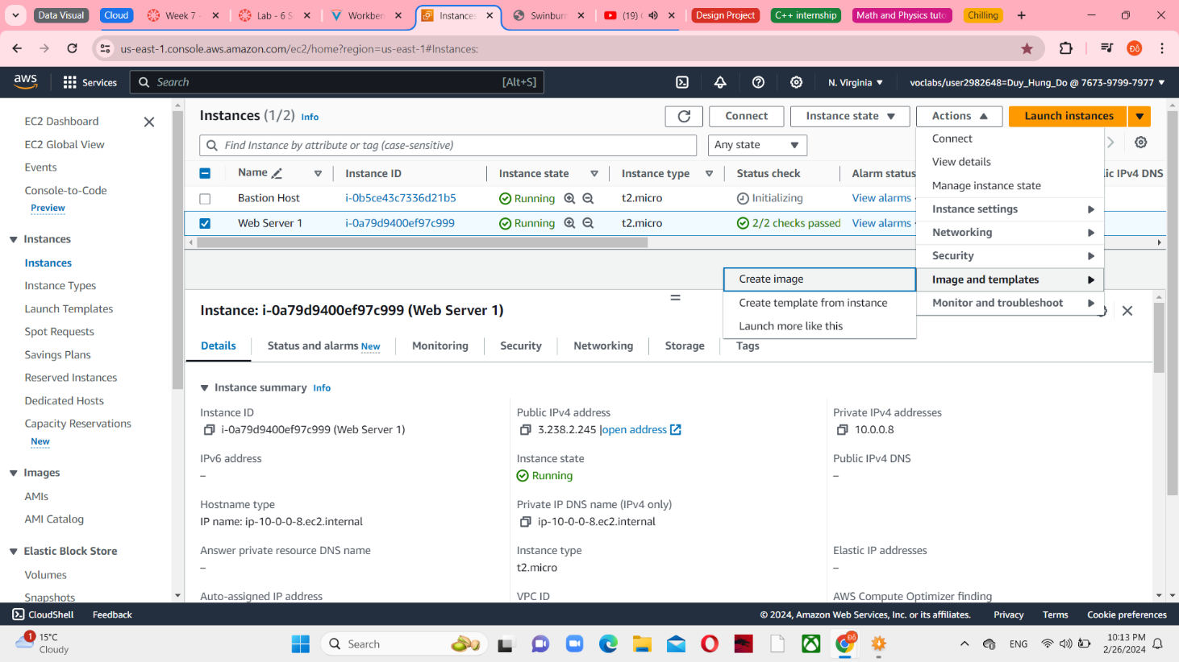

*Figure 2 Create image in Web Server 1*

Configure an image name and image description to set the details

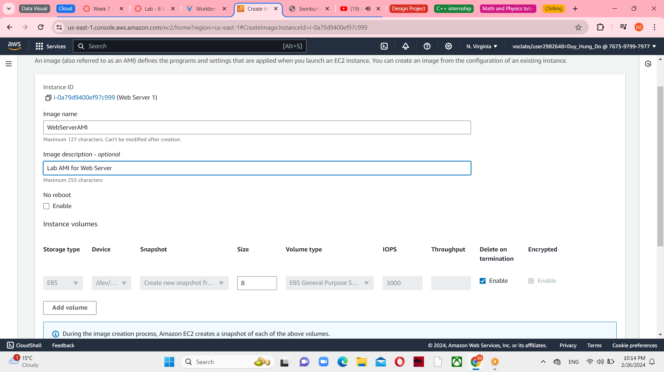

*Figure 3 Create images settings*

Choose Create image and you can see a successful message that image has created

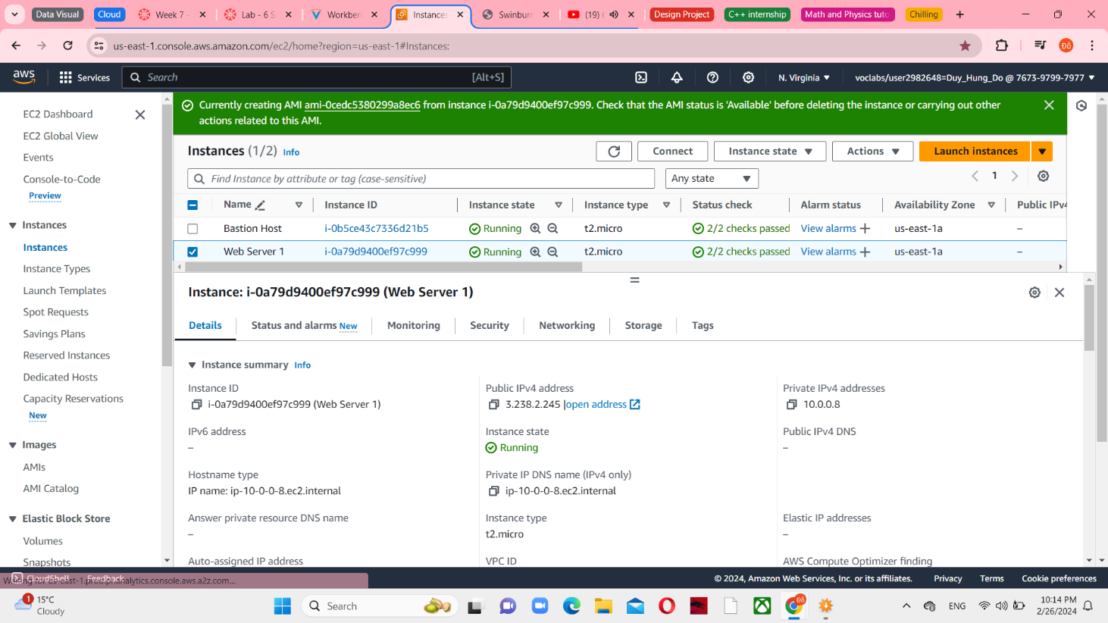

*Figure 4 Created image successfully*

**Task 2: Create a Load Balancer**

Choose Target Groups in the left navigation pane in EC2 selection

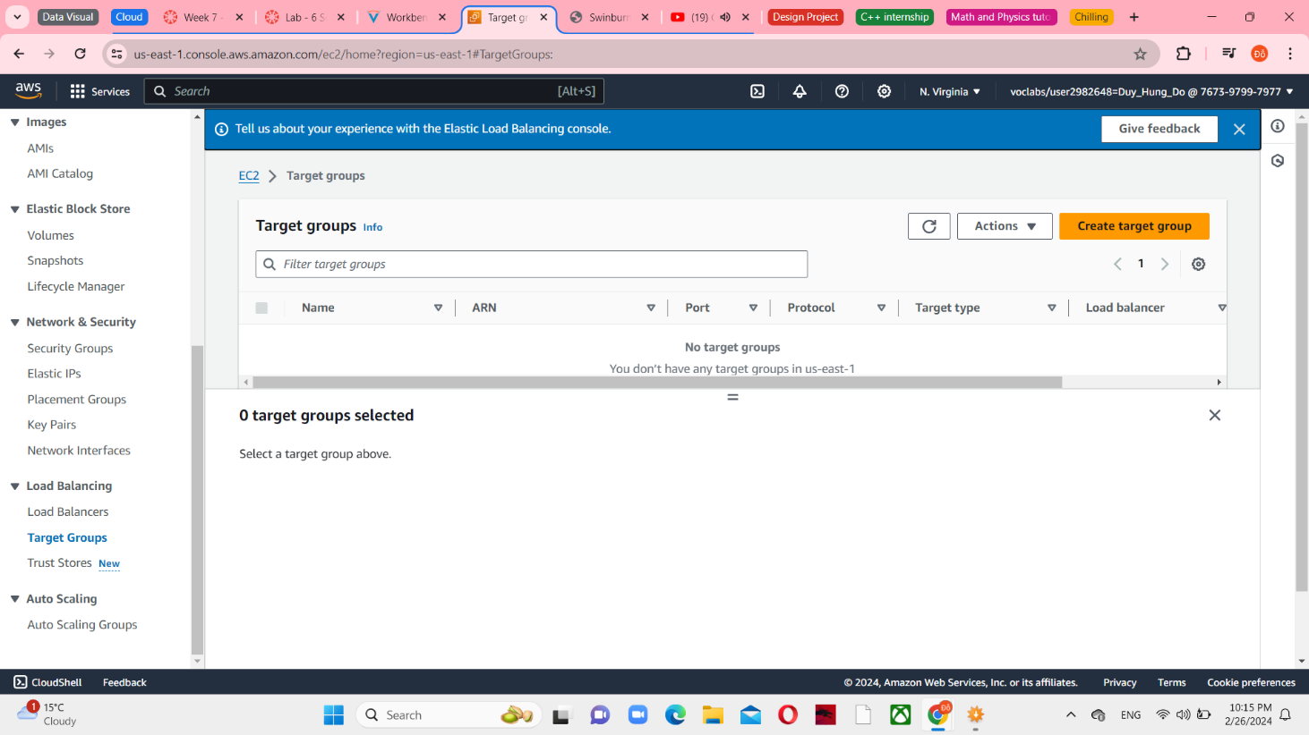

*Figure 5 No Target groups appear*

Create target group with the Instances type, named LapGroup and connect with Lab VPC

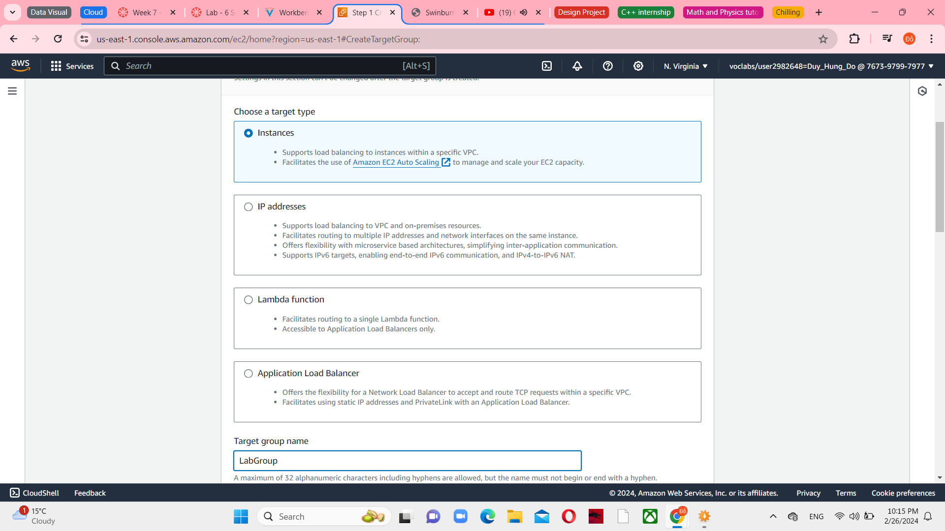

*Figure 6 Target groups settings*

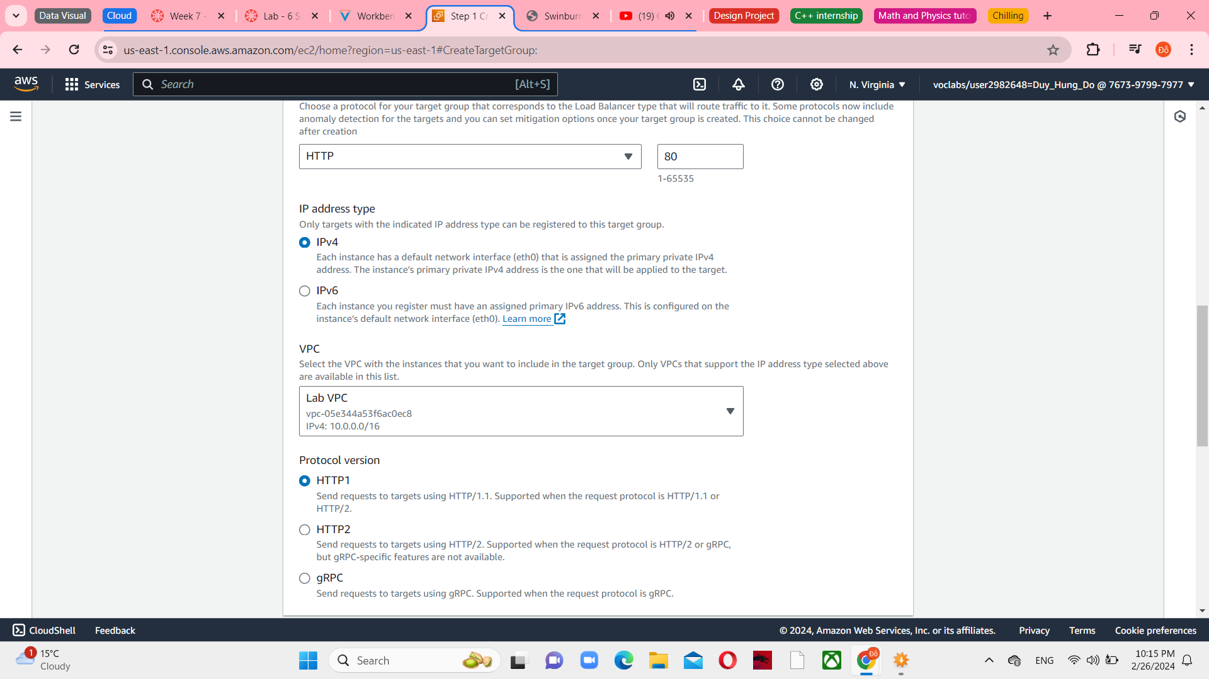

*Figure 7 Connect with Lab VPC*

After that, choose Next and the Register targets screen appears that will respond to requests from the Load Balancer.

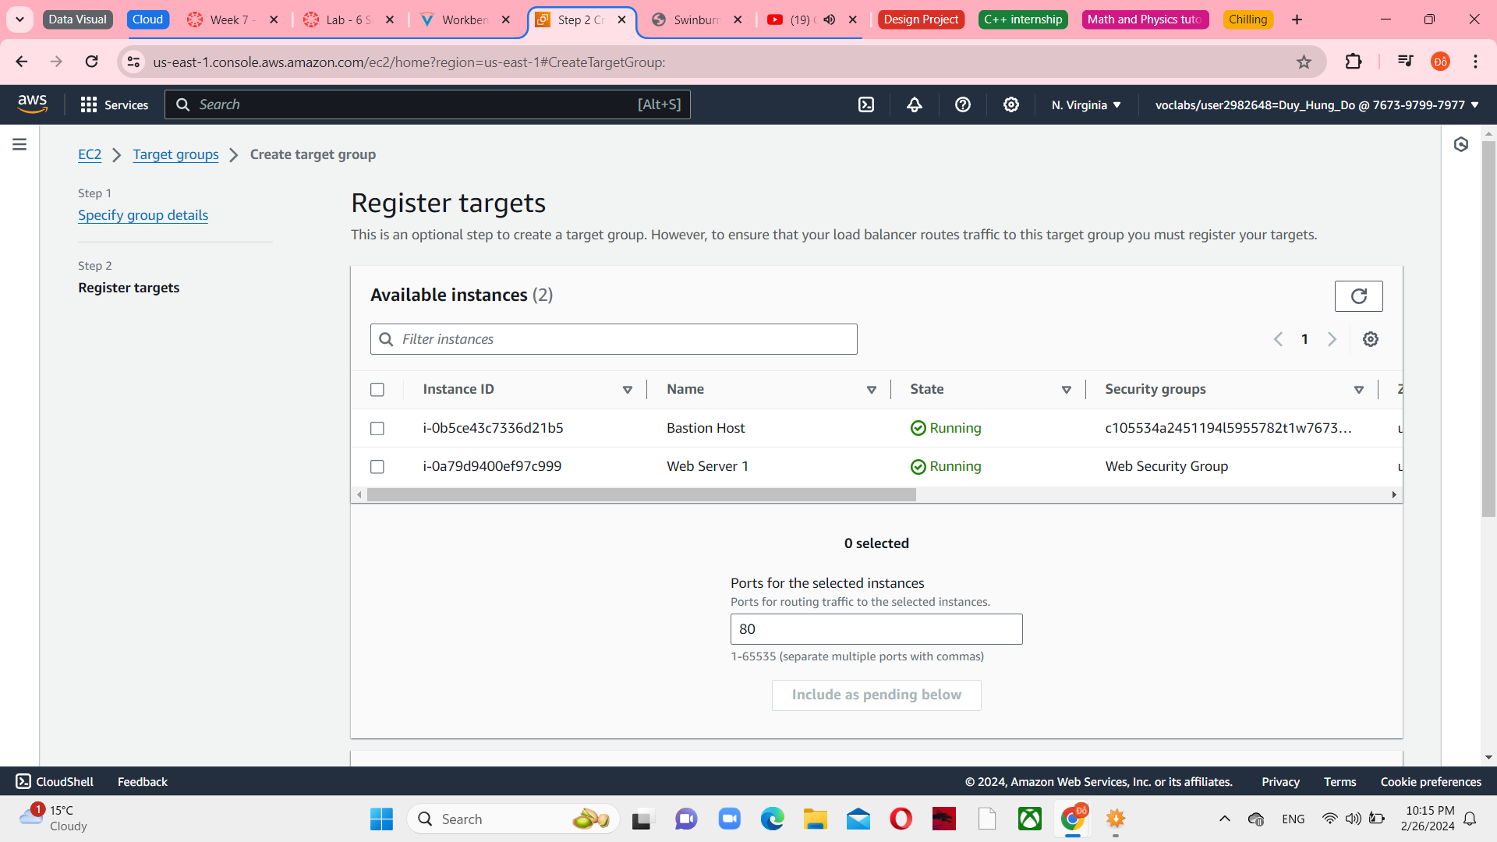

*Figure 8 Register targets are created*

Create load balancer and apply load balancer. You can see it in the first line.

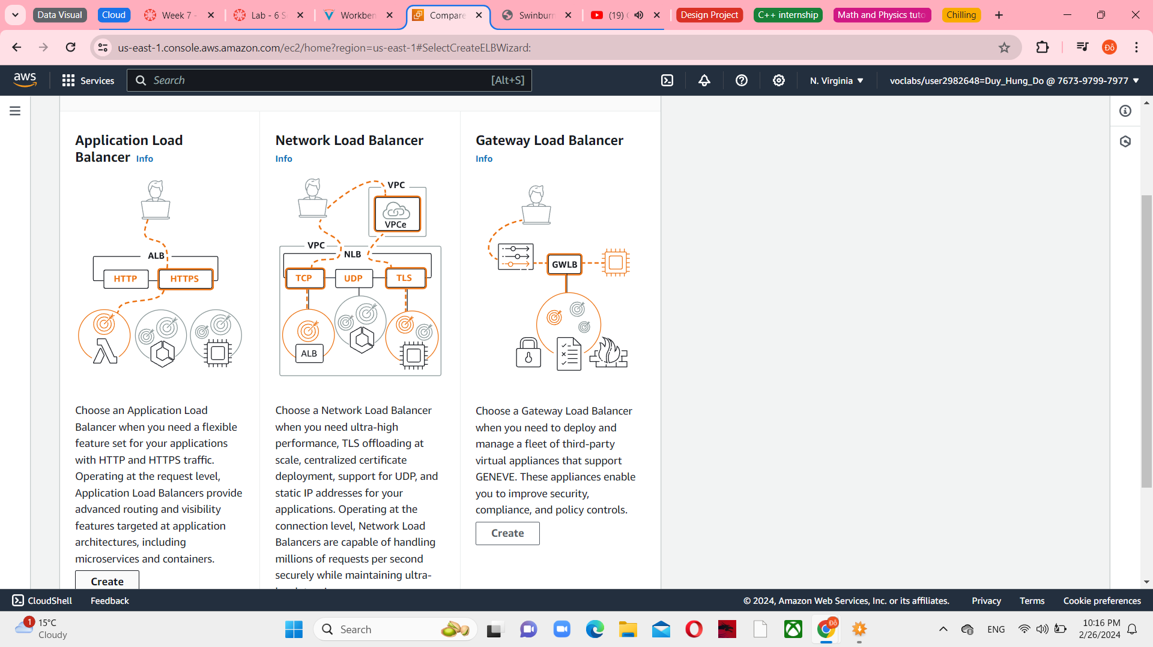

*Figure 9 Load Balancers menu*

Name of Load balancer is LabELB, still connect with Lab VPC, choose 2 public subnets with 2 regions 1a and 1b, respectively. And now you have selected Public Subnet 1 and Public Subnet 2

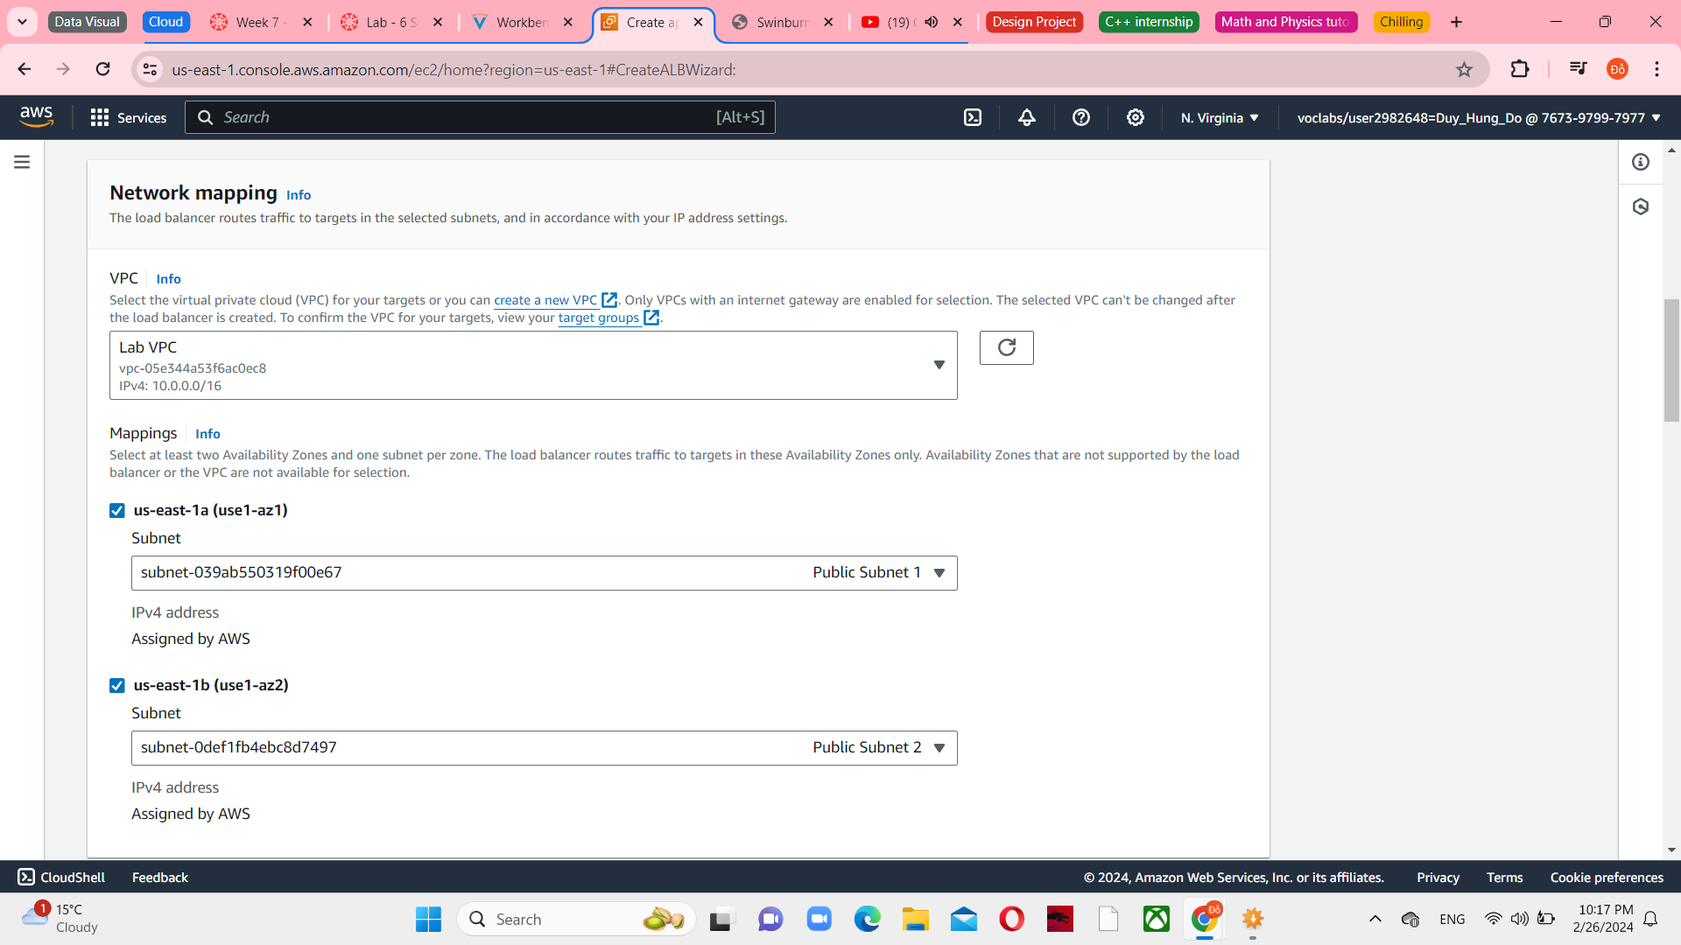

*Figure 10 Network mapping in Load balancer*

In the Security groups section, select Web Security Group – the only one that appears

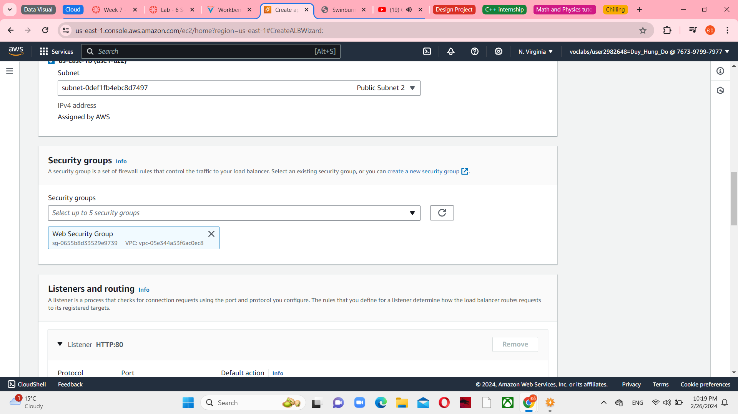

*Figure 11 Security Group in Load balancer*

Set the LabGroup for the Listener HTTP: 80 row, it is in the Default action

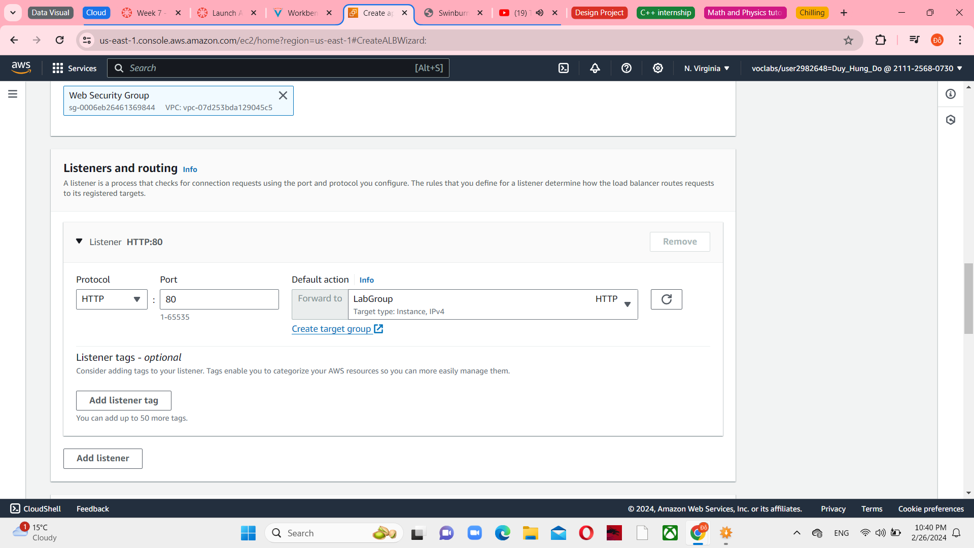

*Figure 12 Listeners and routing in Load balancer*

Choose Create load balancer and view it, you can see a successfully message. And the load balancer will show a state of provisioning.

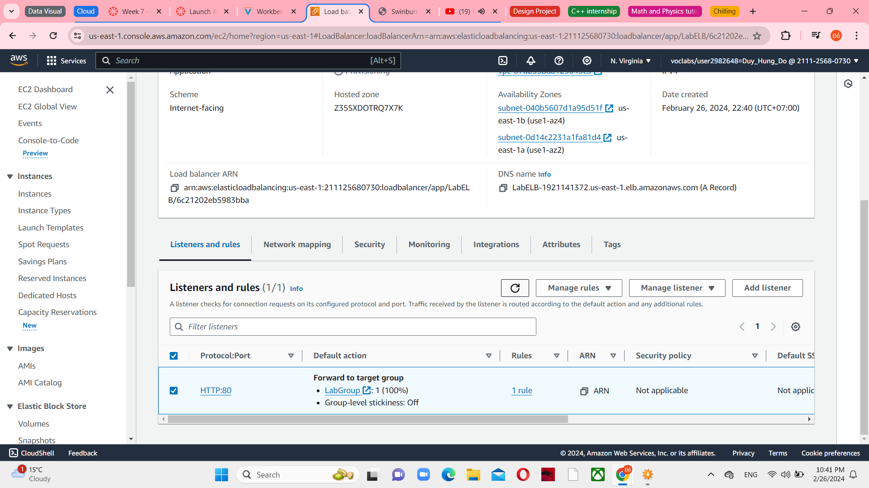

*Figure 13 Create load balancer*

**Task 3: Create a Launch Template and an Auto Scaling Group**

Choose Launch Templates in the left navigation pane and then choose Create launch template.

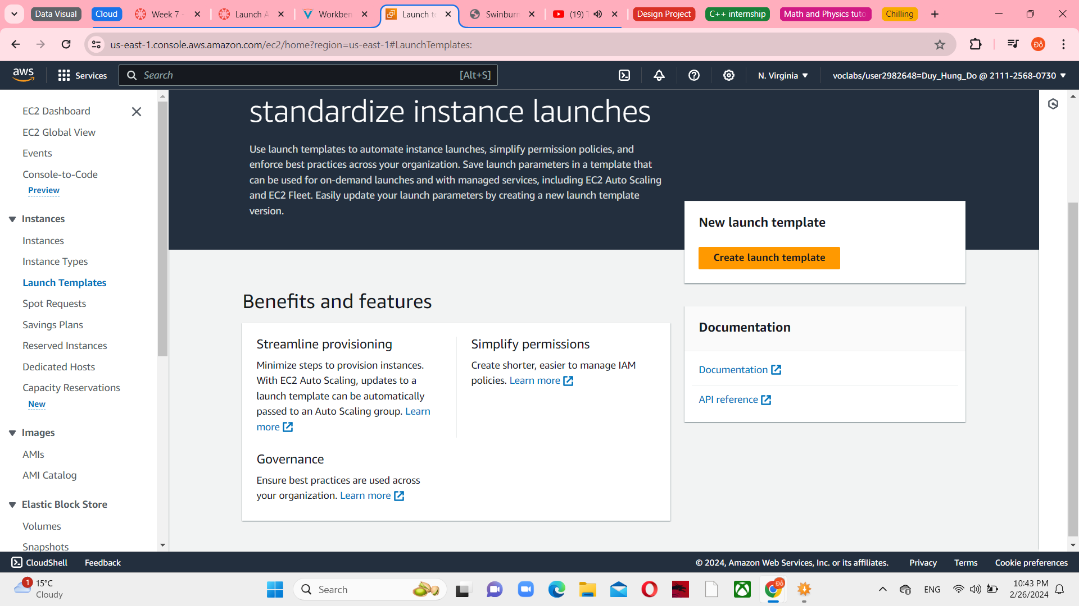

*Figure 14 Launch Templates in EC2 console*

Configure the settings and create for the following requirements: LabConfig is a template name and select Provide guidance to help me set up a template that I can use with EC2 Auto Scaling

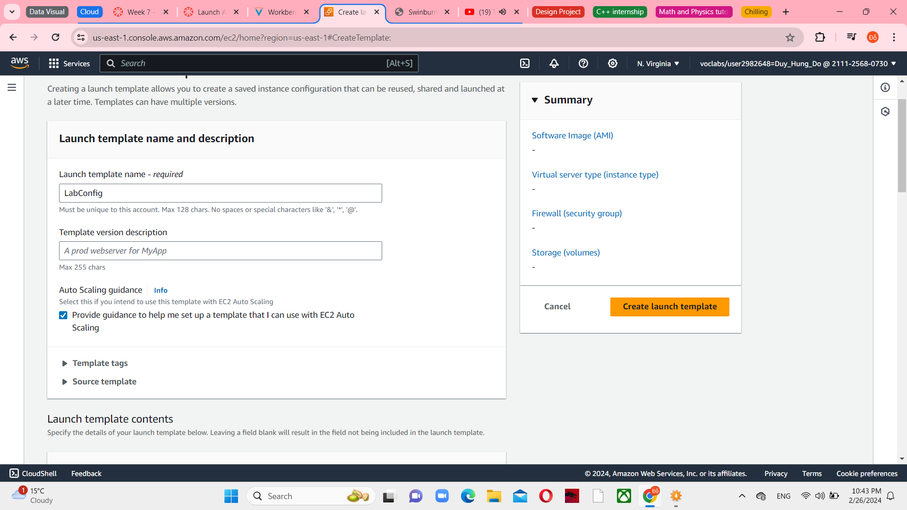

*Figure 15 Launch template name and description*

Still choose Web Server AMI owned.

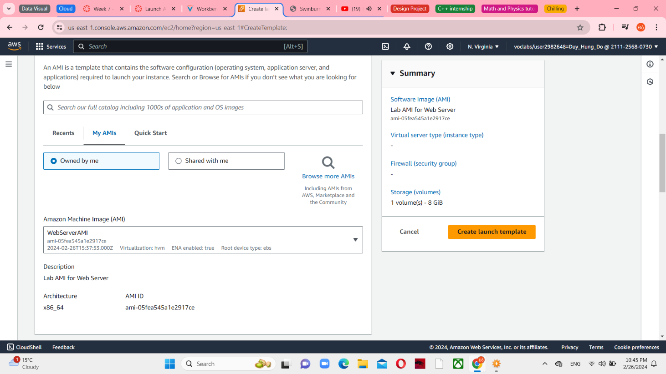

*Figure 16 Amazon Machine Image*

Choose a t2.micro for an instance type and vockey for key pair (login).

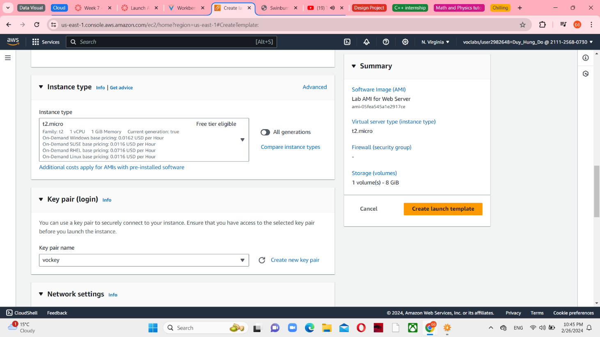

*Figure 17 Instance type and Key pair (login)*

In Firewall (security groups), choose an existing security group. The name is Web Security Group.

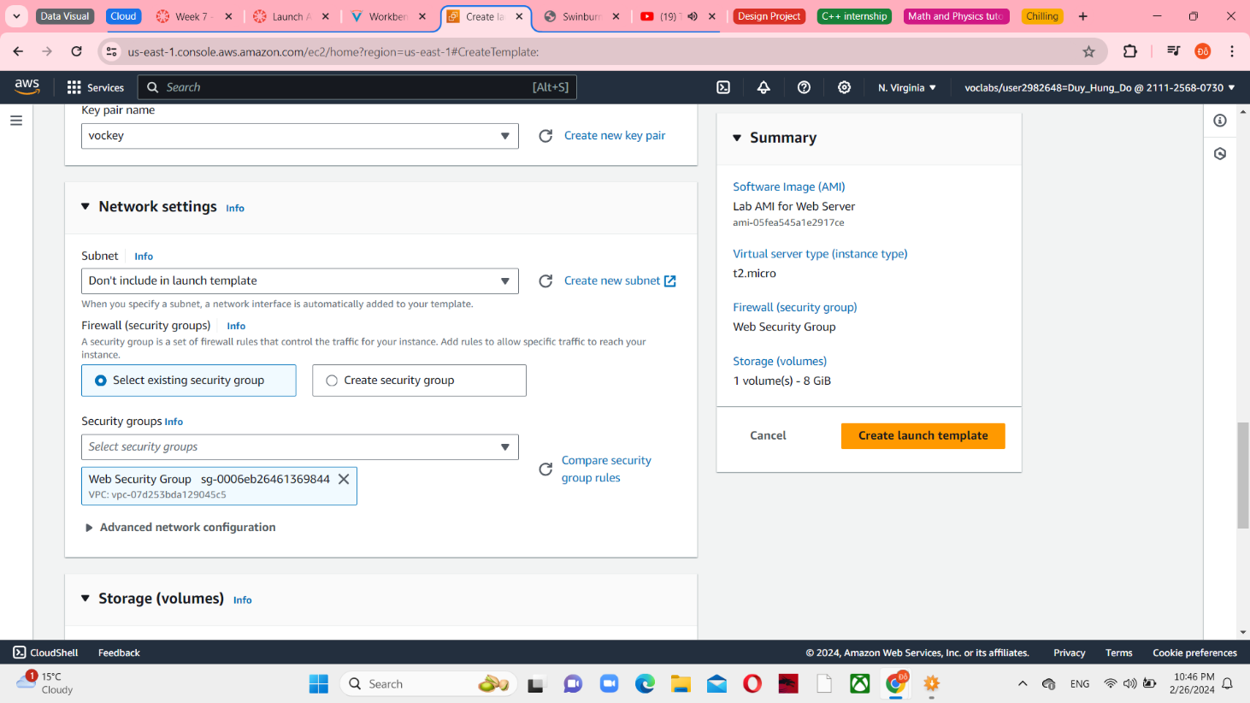

*Figure 18 Networks settings*

Enable the Detailed CloudWatch monitoring

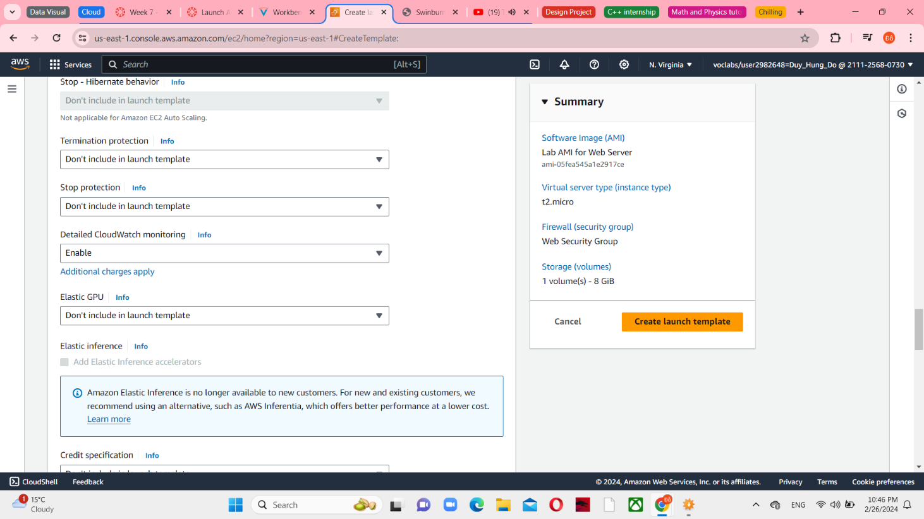

*Figure 19 Advanced details*

Choose Create launch template and you can see the LabConfig in Success dialog.

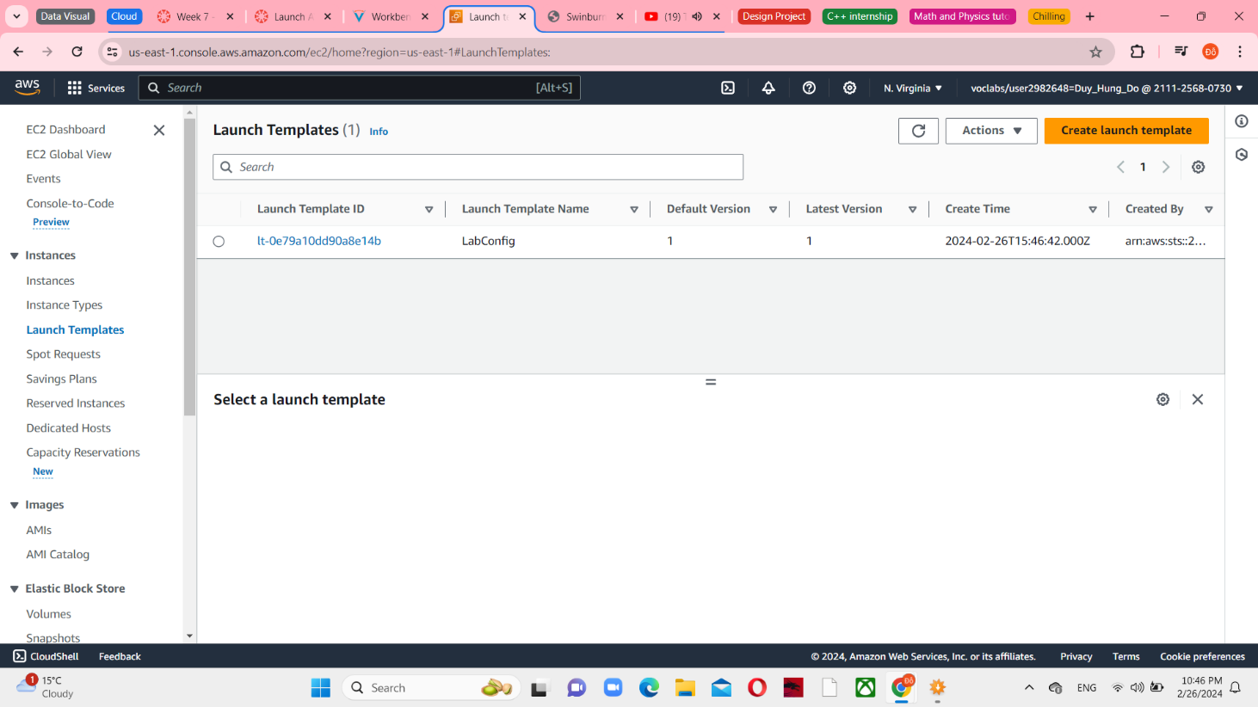

*Figure 20 LabConfig in Launch Templates*

From the Actions menu, choose Create Auto Scaling group.

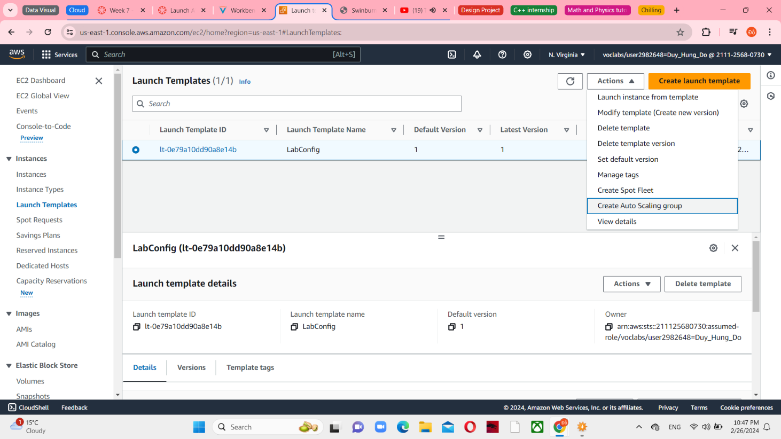

*Figure 21 Create Auto Scaling group*

In step 1, set the Auto Scaling group name is Lab Auto Scaling Group. LabConfig is selected for Launch template

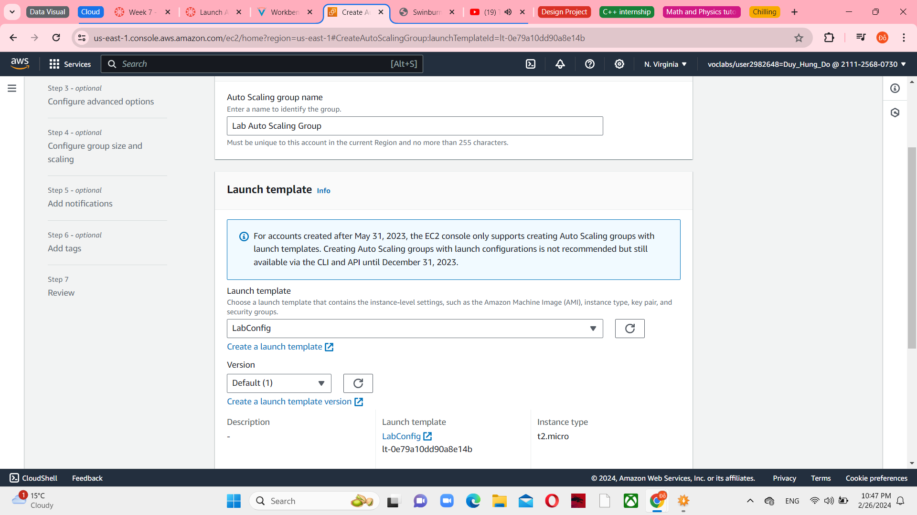

*Figure 21 Choose launch template or configuration*

In step 2, choose Lab VPC and associated 2 private subnet for each region. Particularly, choose Private Subnet 1 in us-east-1a and Private Subnet 2 in us-east-1b

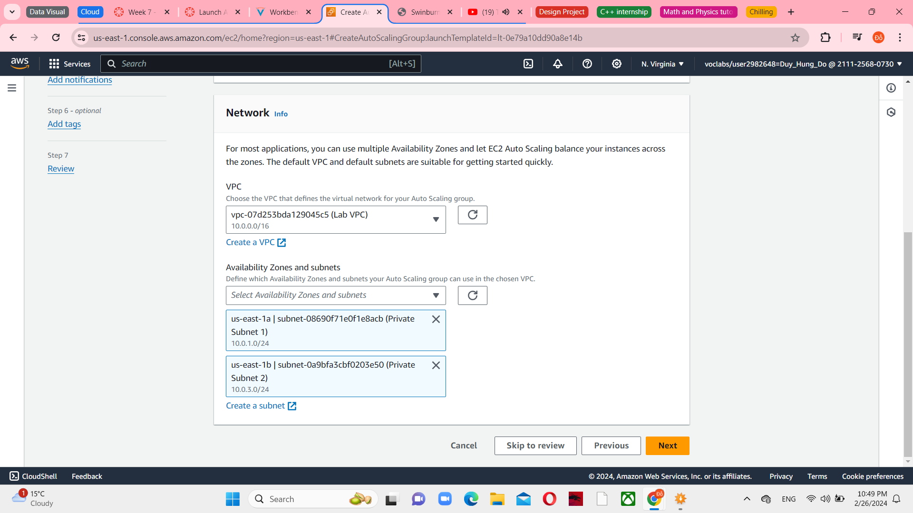

*Figure 22 Choose instance launch options*

In step 3, Attach to an existing load balancer is selected. After that, select LabGroup as an Existing load balancer target groups.

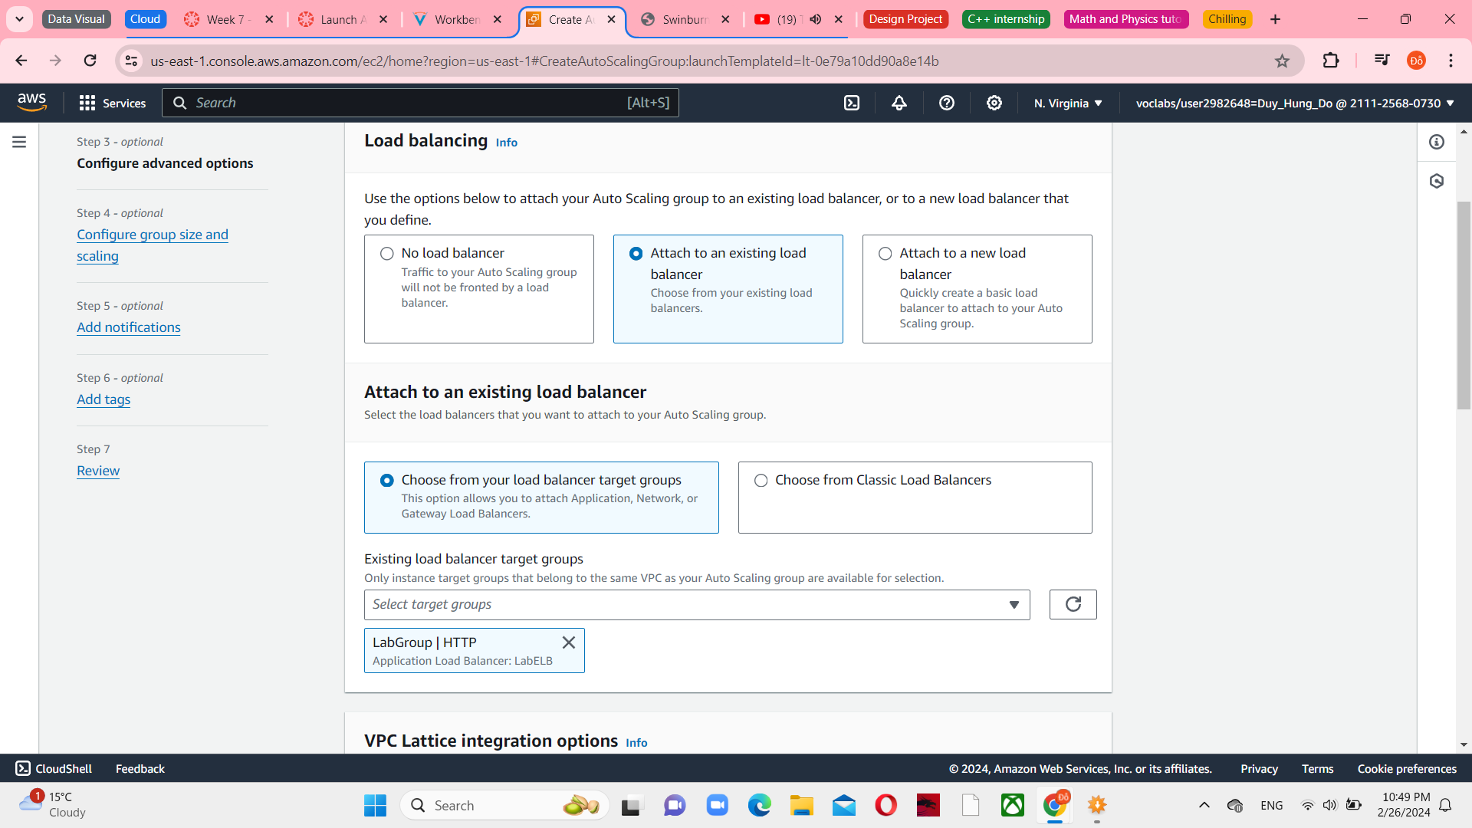

*Figure 23 Configure advanced options*

Under Group size, configure the Desired and Minimum capacity are 2, Maximum capacity is 6.

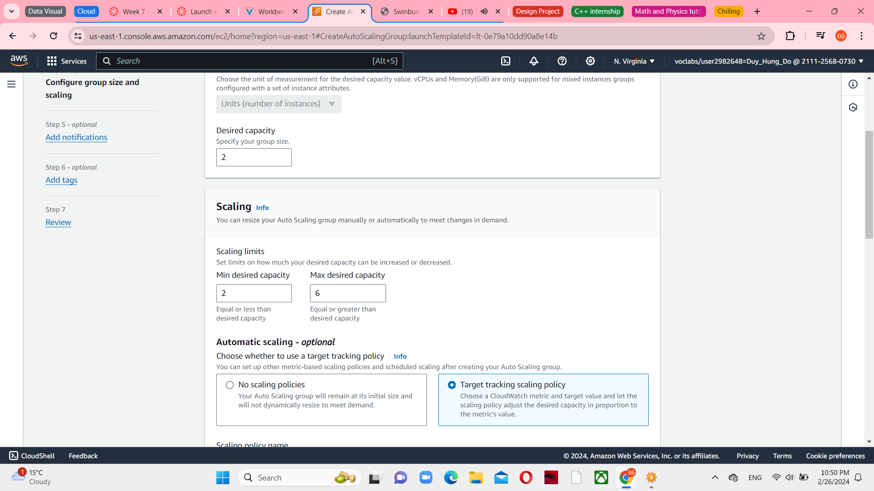

*Figure 24 Configure group size and scaling policies-optional*

In step 5, auto Scaling can send a notification when a scaling event takes place. You will use the default settings

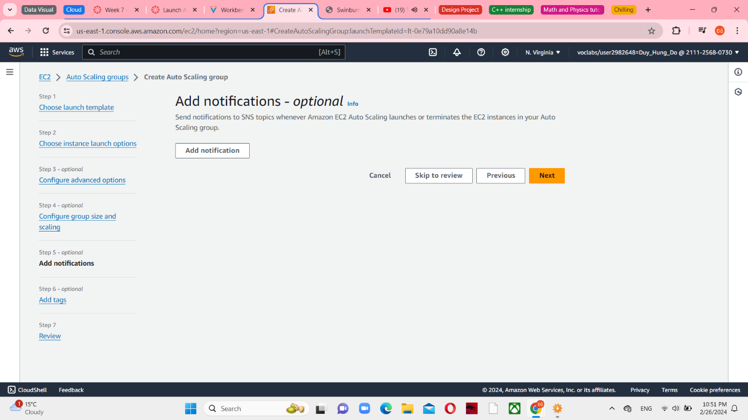

*Figure 25 Add nofications - optional*

In step 6, tags applied to the Auto Scaling group will be automatically propagated to the instances that are launched. Choose Add tag and fill the “Name” as a key and “Lab Instance” as a value.

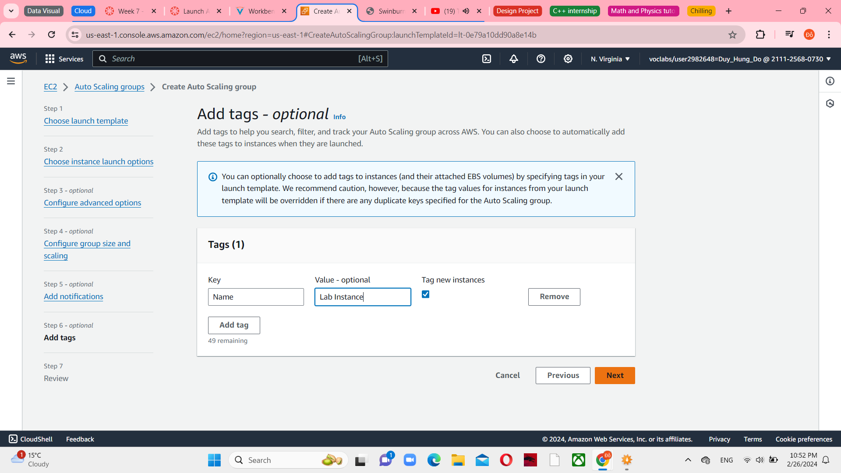

*Figure 26 Add tags-optional*

In step 6, you can review of your Auto Scaling group and then Create Auto Scaling group.

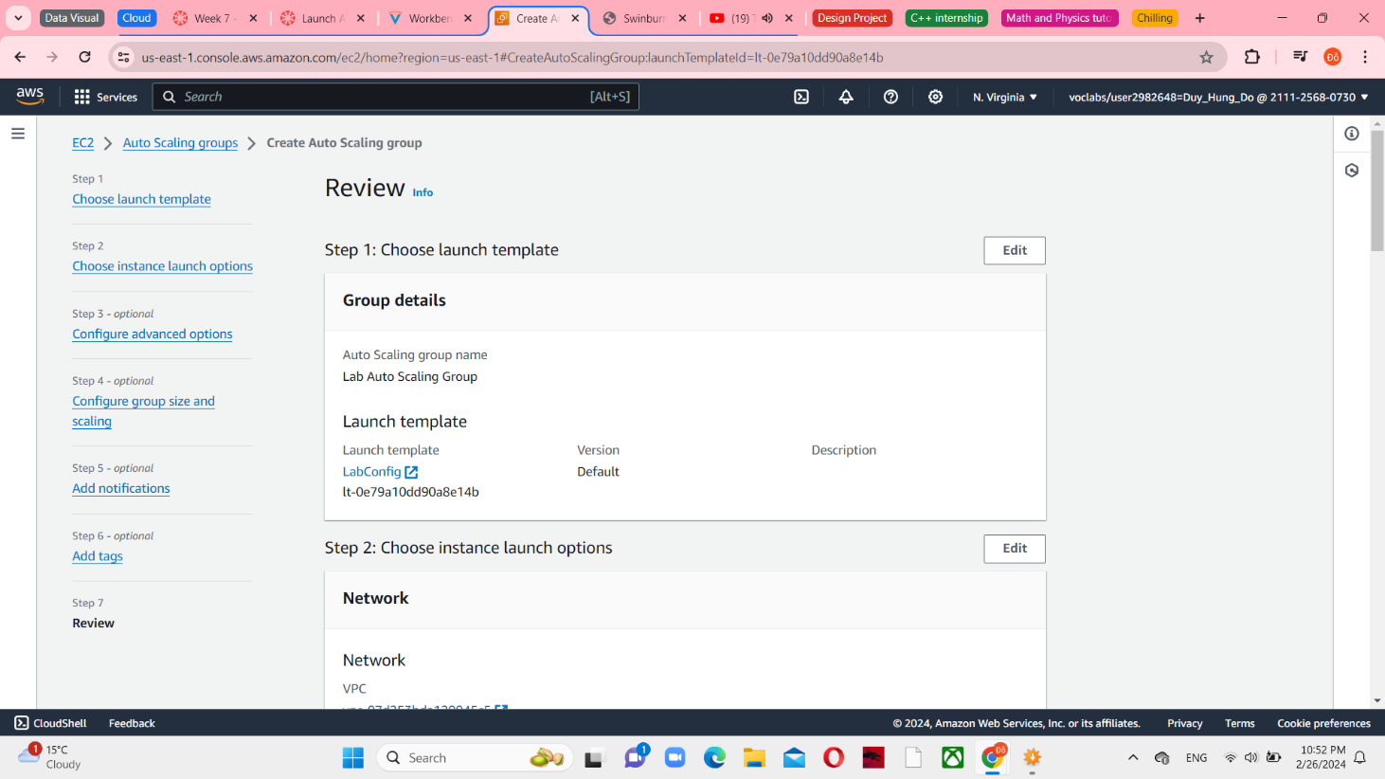

*Figure 27 Review*

Your Auto Scaling group will start with no instances, however, additional instances will be deployed until the Desired count of 2 instances is reached.

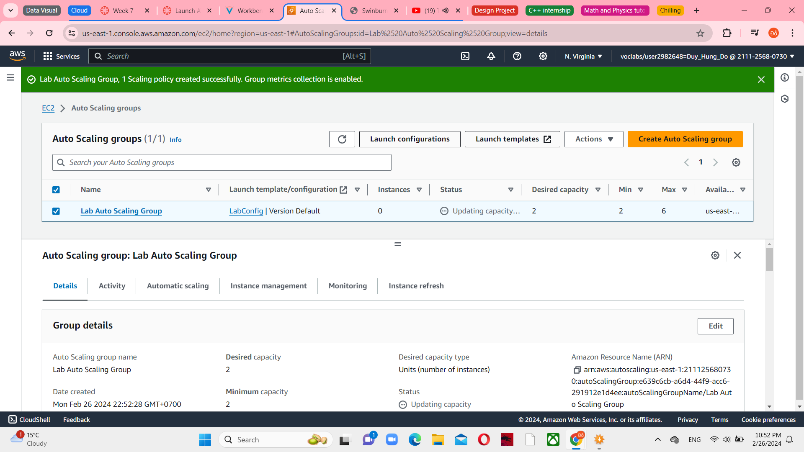

*Figure 28 Created Auto Scaling group successfully*

**Task 4: Verify that Load Balancing is Working**

Choose Instances in the left navigation pane, you can see 2 Lab Instance has initializing and the running state.

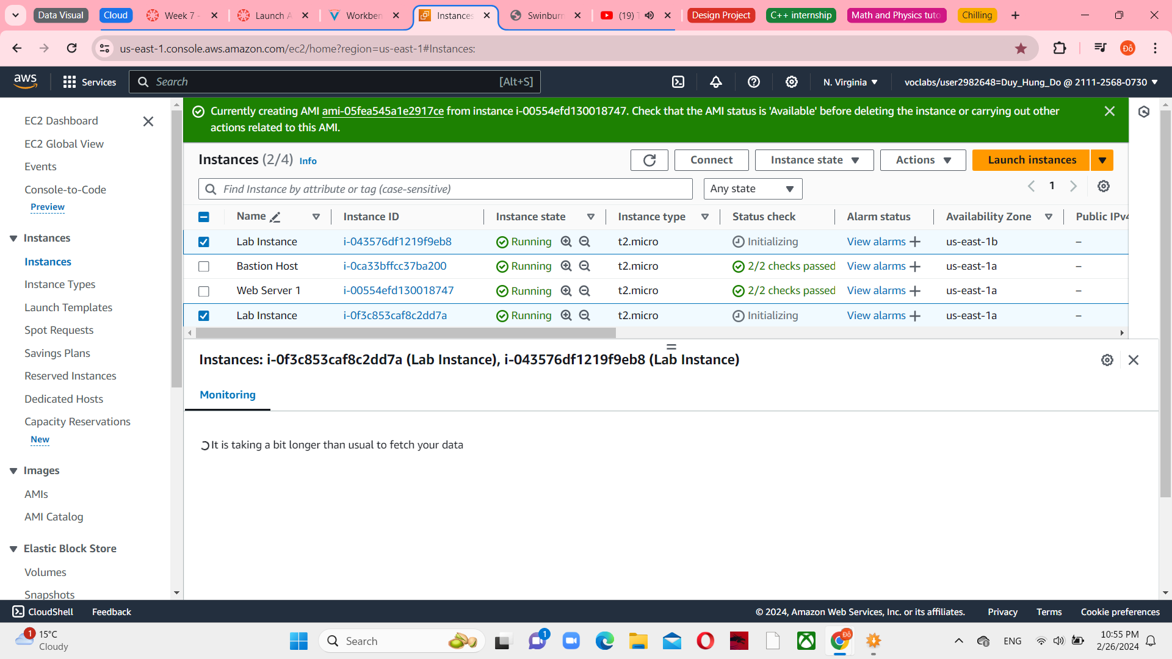

*Figure 29 Instances console*

Choose against Target Groups and select LabGroup. In this targets tab, there are 2 Lab Instances should be listed in the target group.

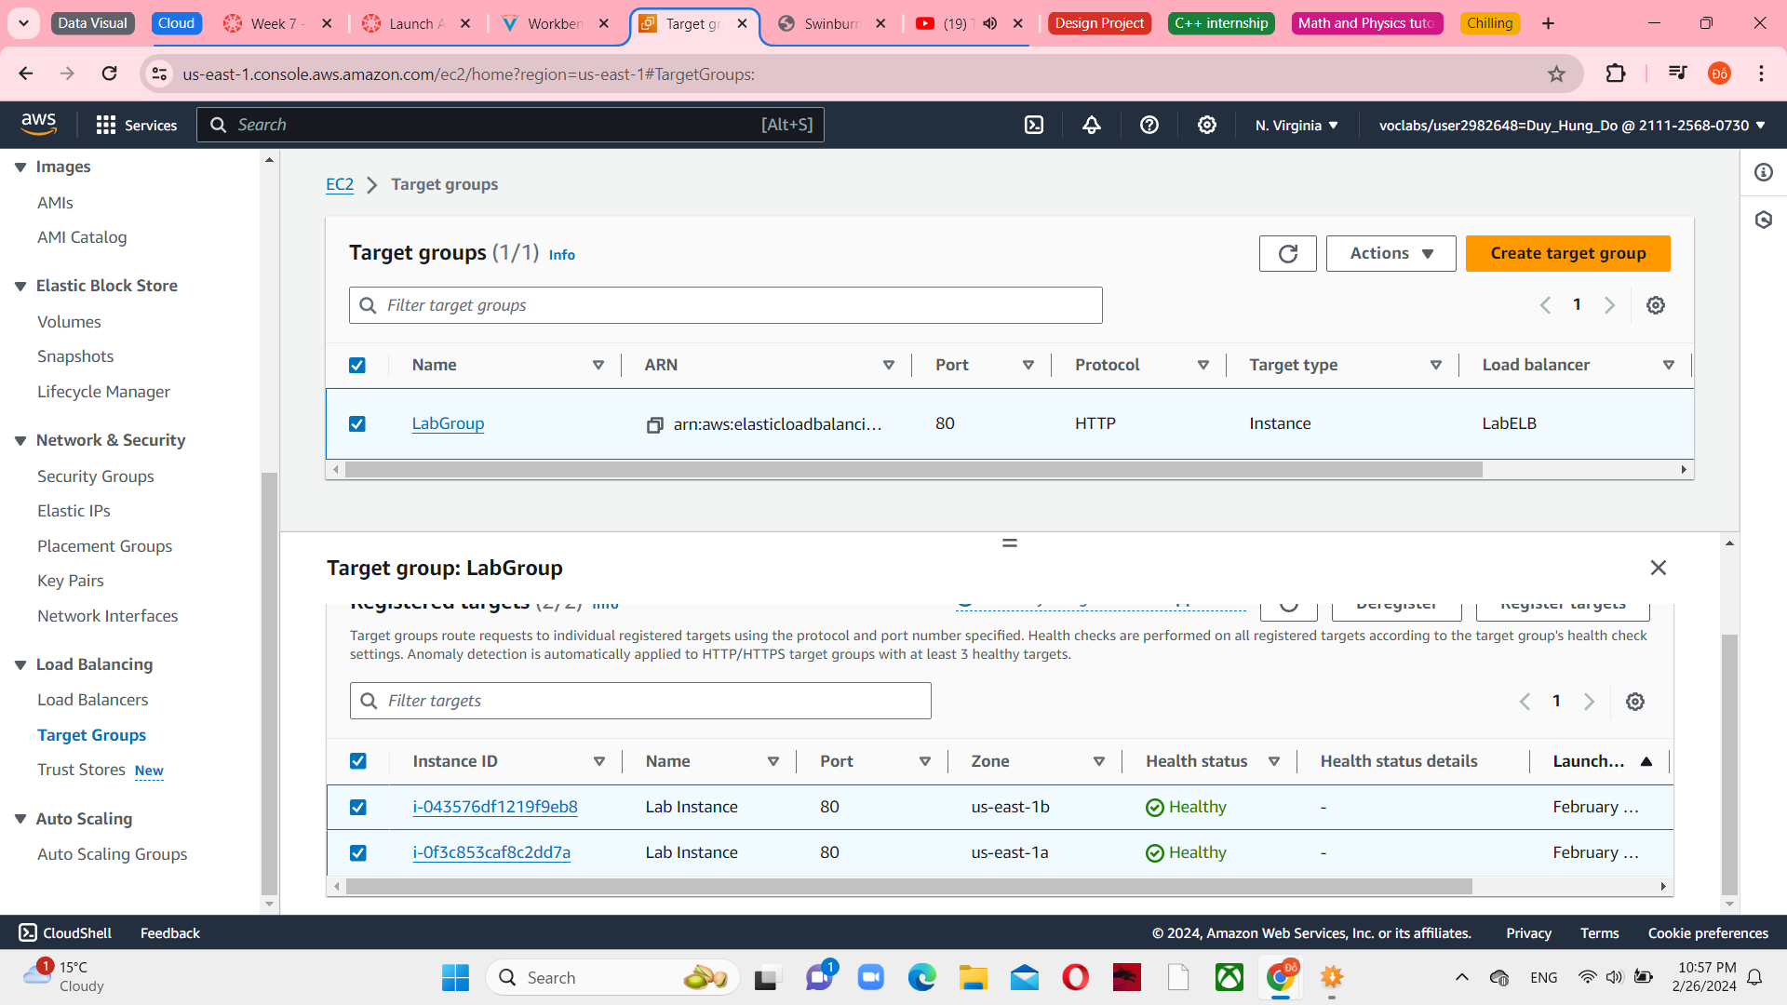

*Figure 30 Target tab in LabGroup*

Wait until the Status of both Lab instances transitions to healthy, and now you can access the auto Scaling group via the Load Balancer

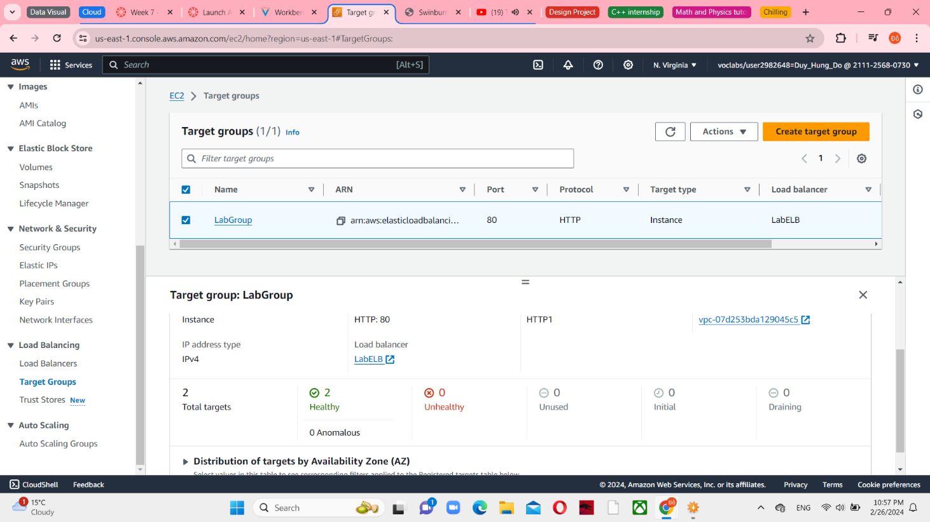

*Figure 31 Healthy instances*

Choose Load Balancers in the left navigation pane, and select the LabELB, You can see the Details pane first, copy the DNS name of the load balancer.

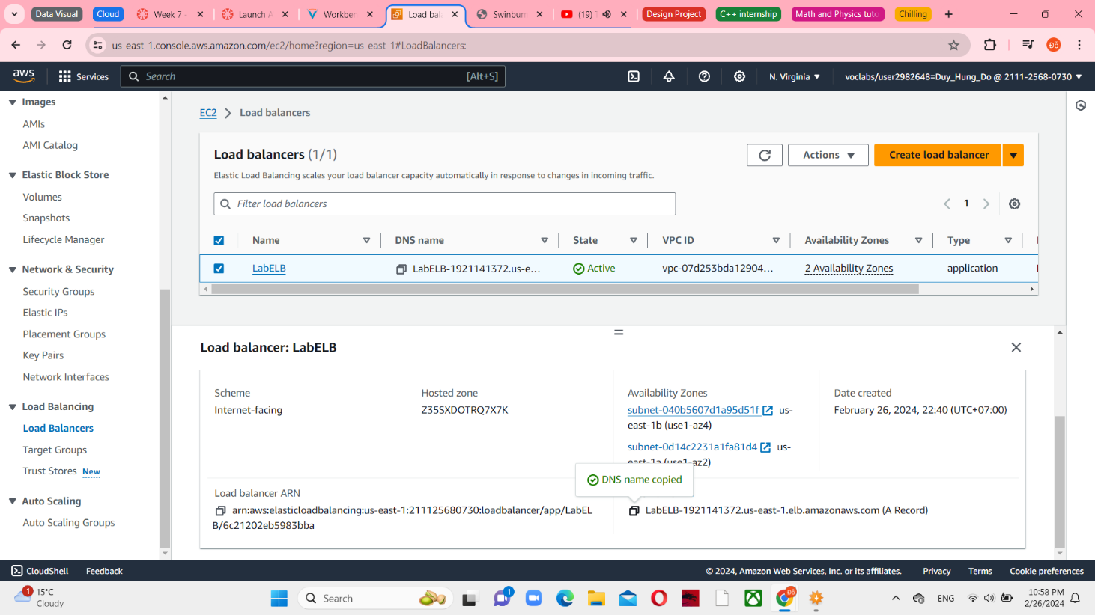

*Figure 32 LabELB in Load balancers*

Open a new web browser tab and paste it. This means that the Load Balancer has received the request, forwarded it to one of the EC2 instances, and subsequently returned the outcome.

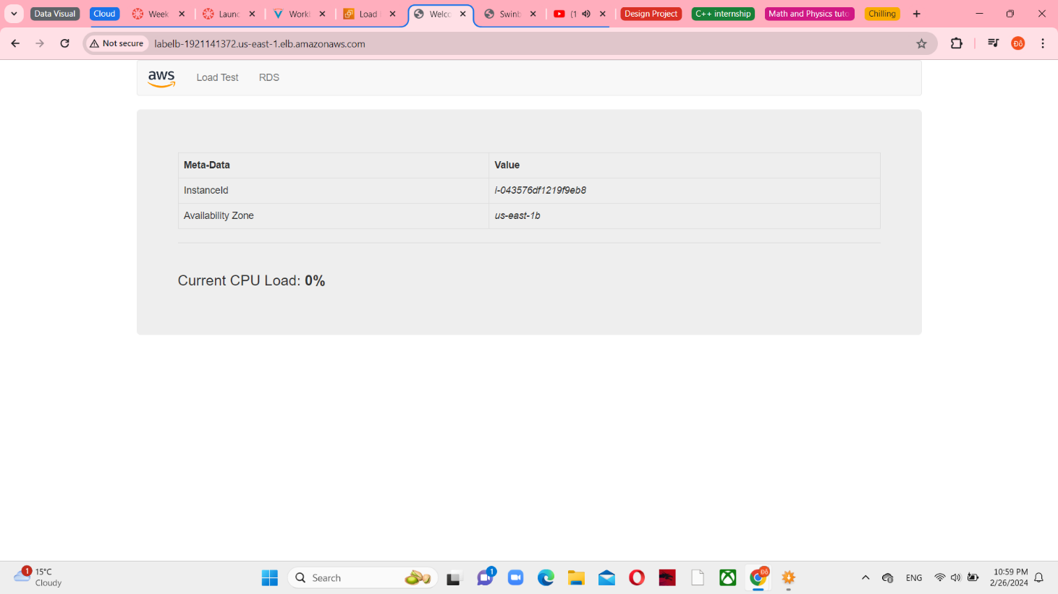

*Figure 33 LabELB web server*

**Task 5: Test Auto Scaling**

Return to AWS Management Console, select CloudWatch from Services menu.

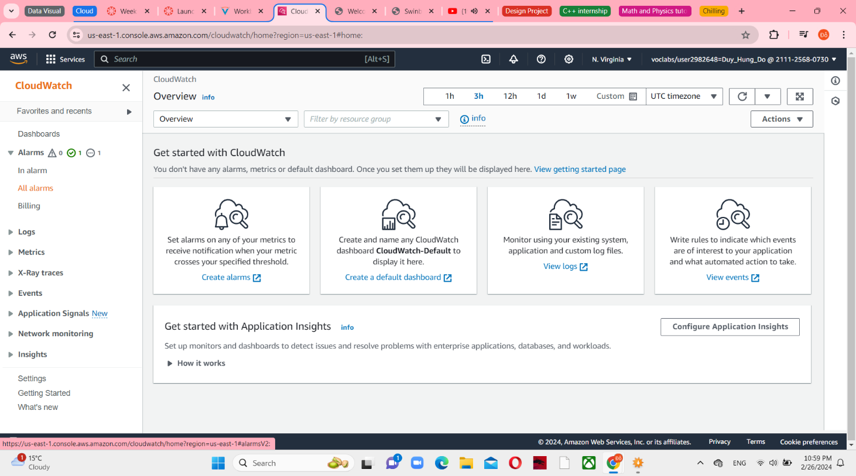

*Figure 34 CloudWatch console*

Choose All alarms in the left navigation pane, you can see an AlarmHigh and AlarmLow. Choose the OK alarm first

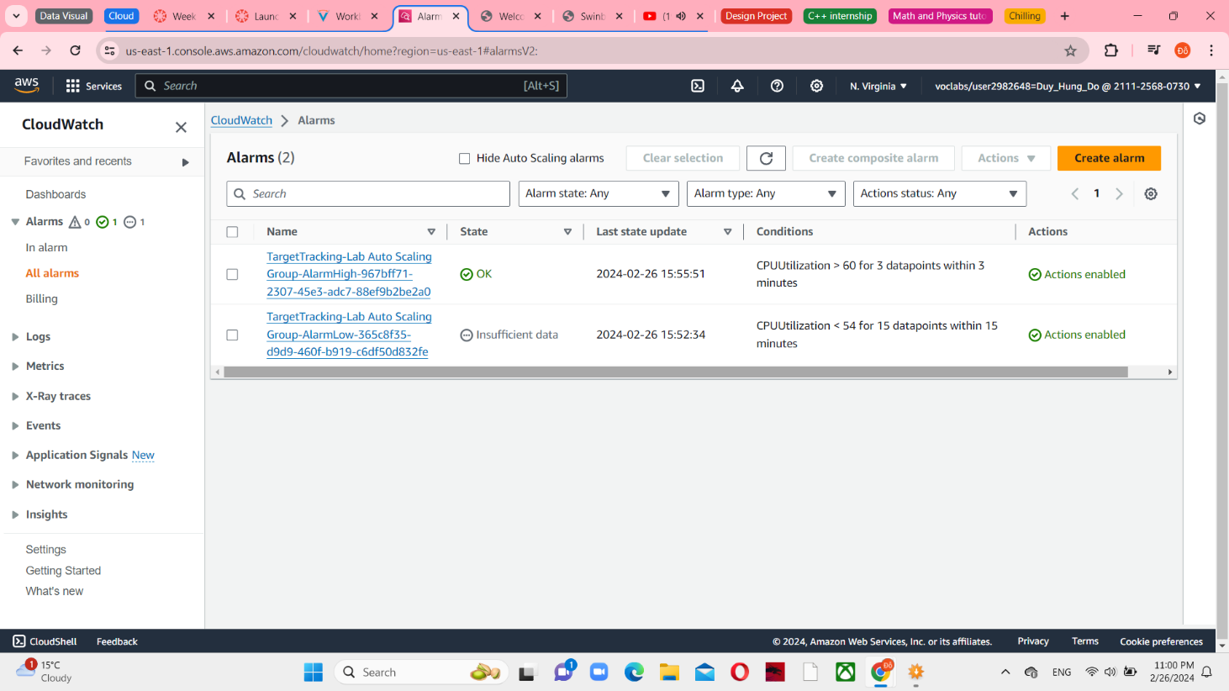

*Figure 35 All alarms in the CloudWatch*

Return to the Browser tab and choose Load Test, you can see 100% CPU Load.

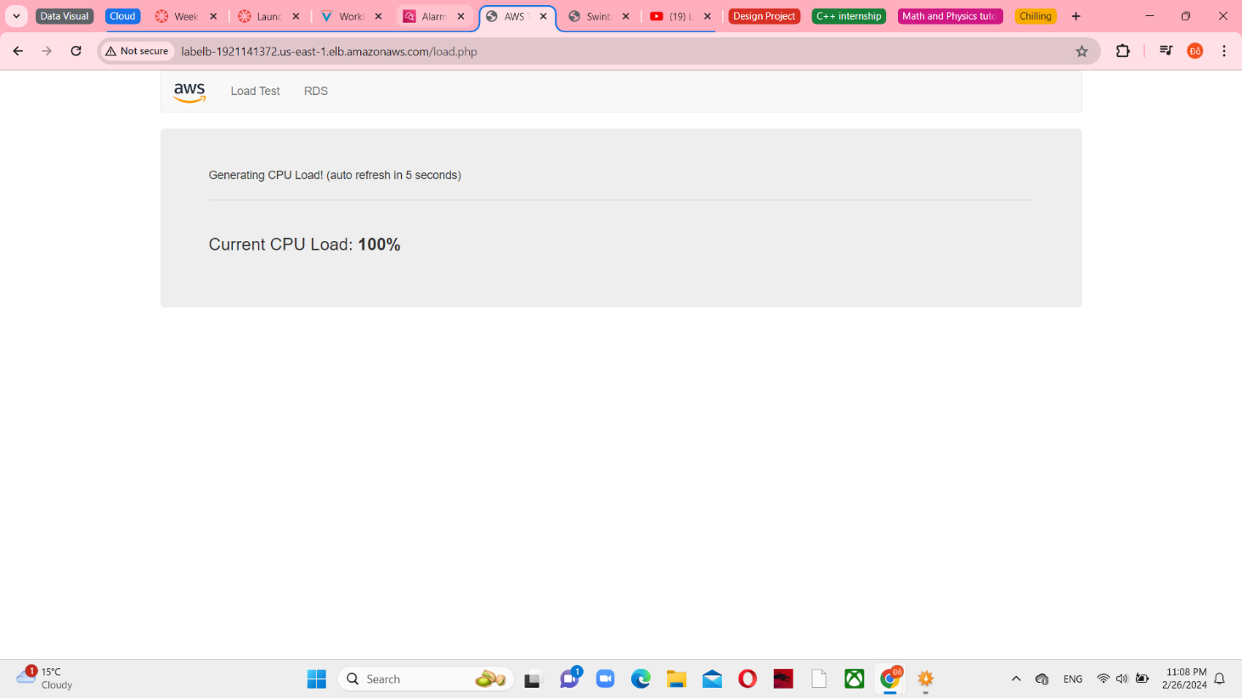

*Figure 36 Load Test Successfully*

Return to the CloudWatch console, wait until the AlarmLow status change to OK and the AlarmHigh status change to In alarm.

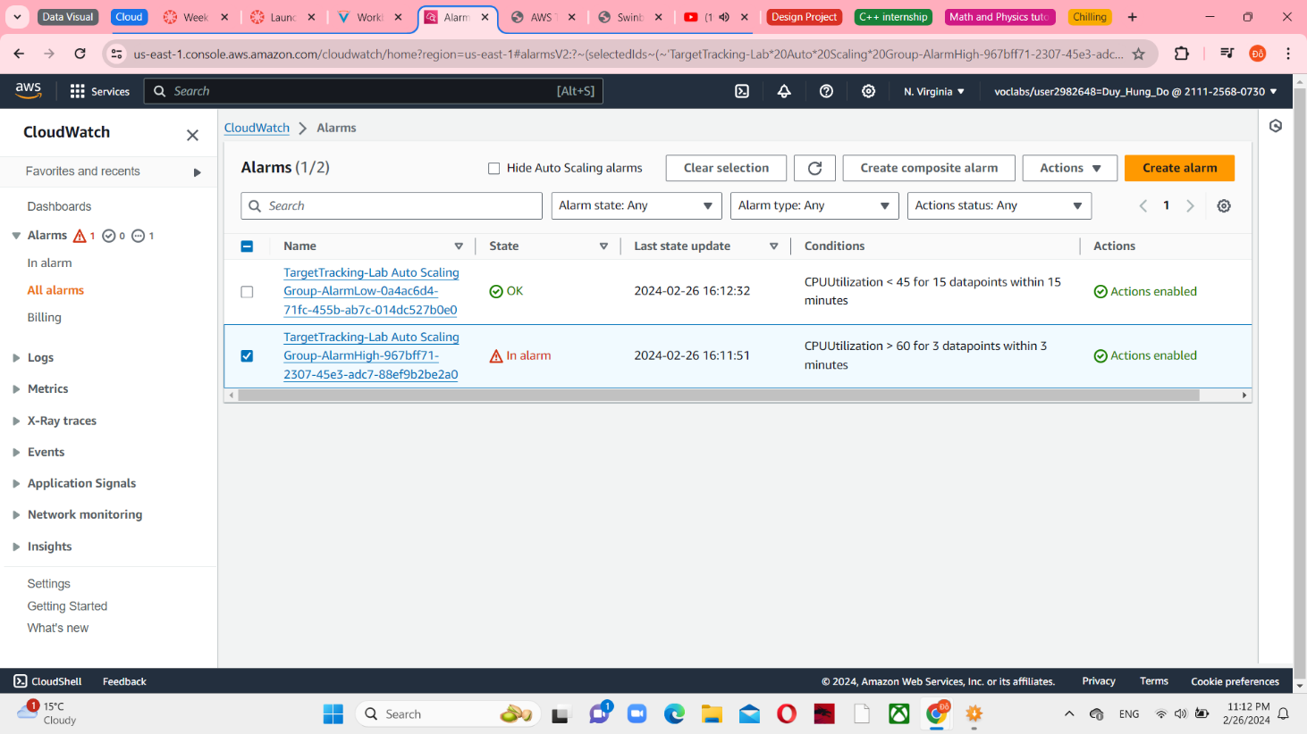

*Figure 37 Alarms’ state changed*

And then, select EC2 in Services menu, choose Instances in the left navigation pane, you can see 4 Lab Instance should be running. The new instance(s) were created by Auto Scaling in response to the CloudWatch alarm.

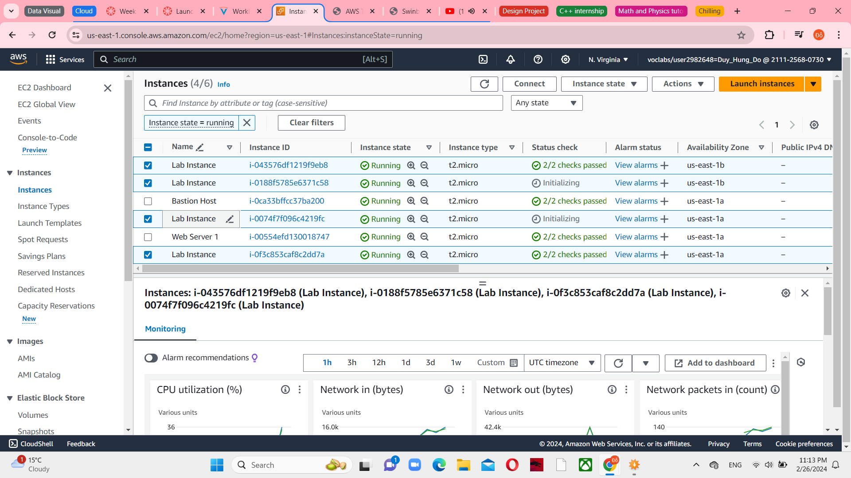

*Figure 38 More Lab instances appeared*

**Task 6: Terminate Web Server 1**

Select Web Server 1 in Instances menu, choose Terminate Instance in Instance state

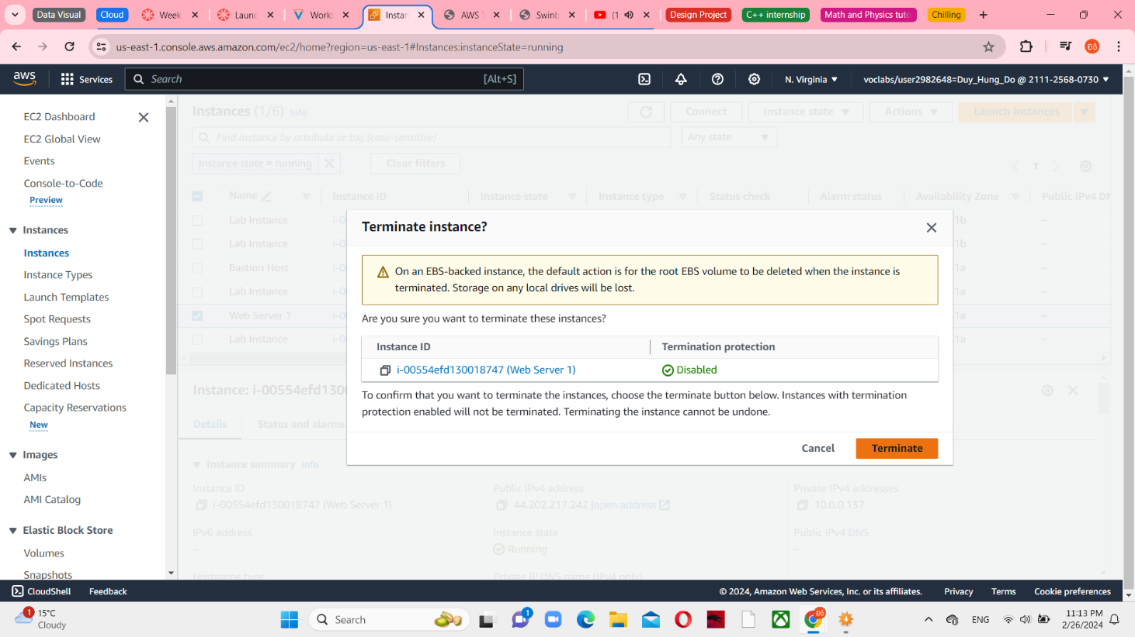

*Figure 39 Terminating Web Server 1*

Choose Terminate and then you will see a successful message.

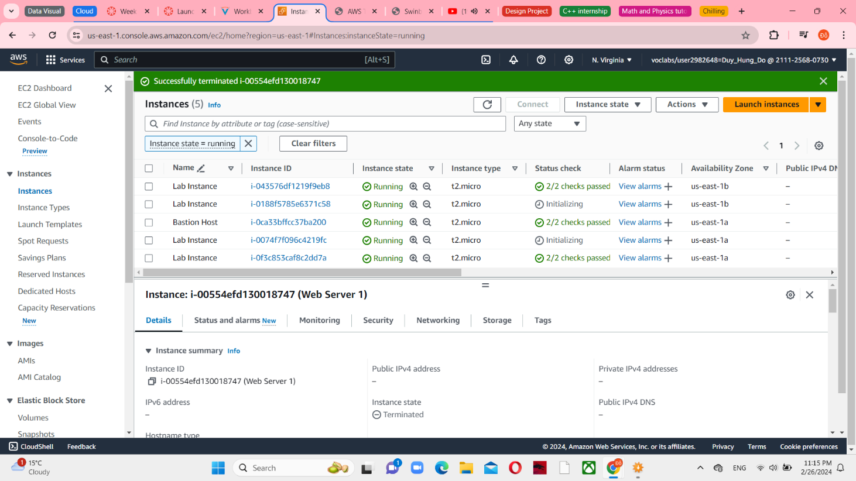

*Figure 40 Successfully terminated*